Practical DevOps with AWS infrastructure

Create AWS infrastructure with Terraform

Build an AWS infrastructure with Terraform through this repo: https://github.com/tuankiet1709/sd5055_aws_infrastructure

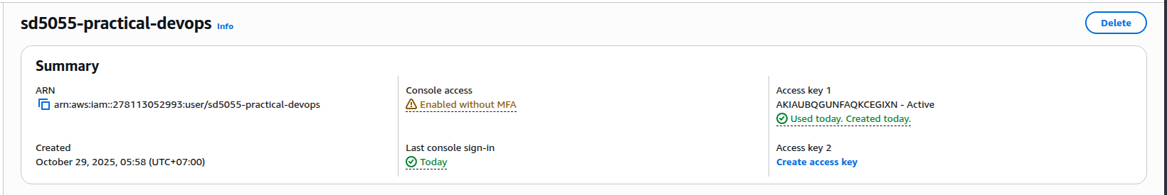
- First, I created IAM user for practical devops traininig (SD5055-practical-devops)
- Then, set IAM user to aws cli local with access key and secret access key
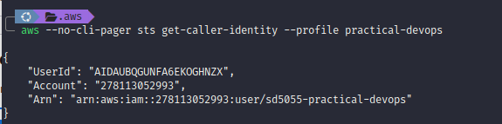
- We will need to run `terraform init` to init the terraform infrastructure
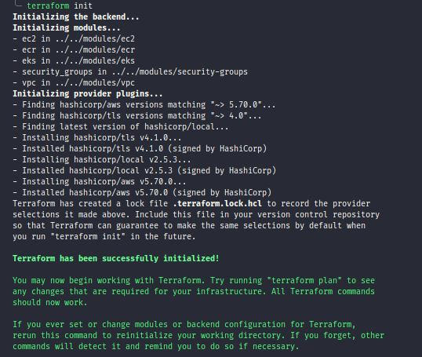

- After initializing terraform successfully, we can use `terraform apply` to create the aws services that we defined in terraform
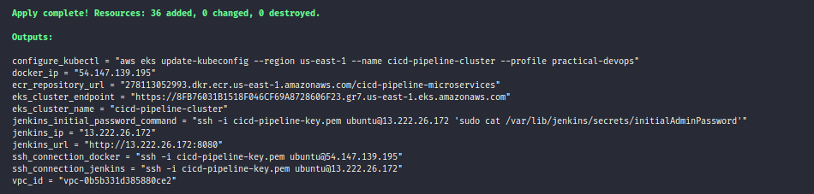
- After applying terraform successfully, we can see all resources we defined on AWS

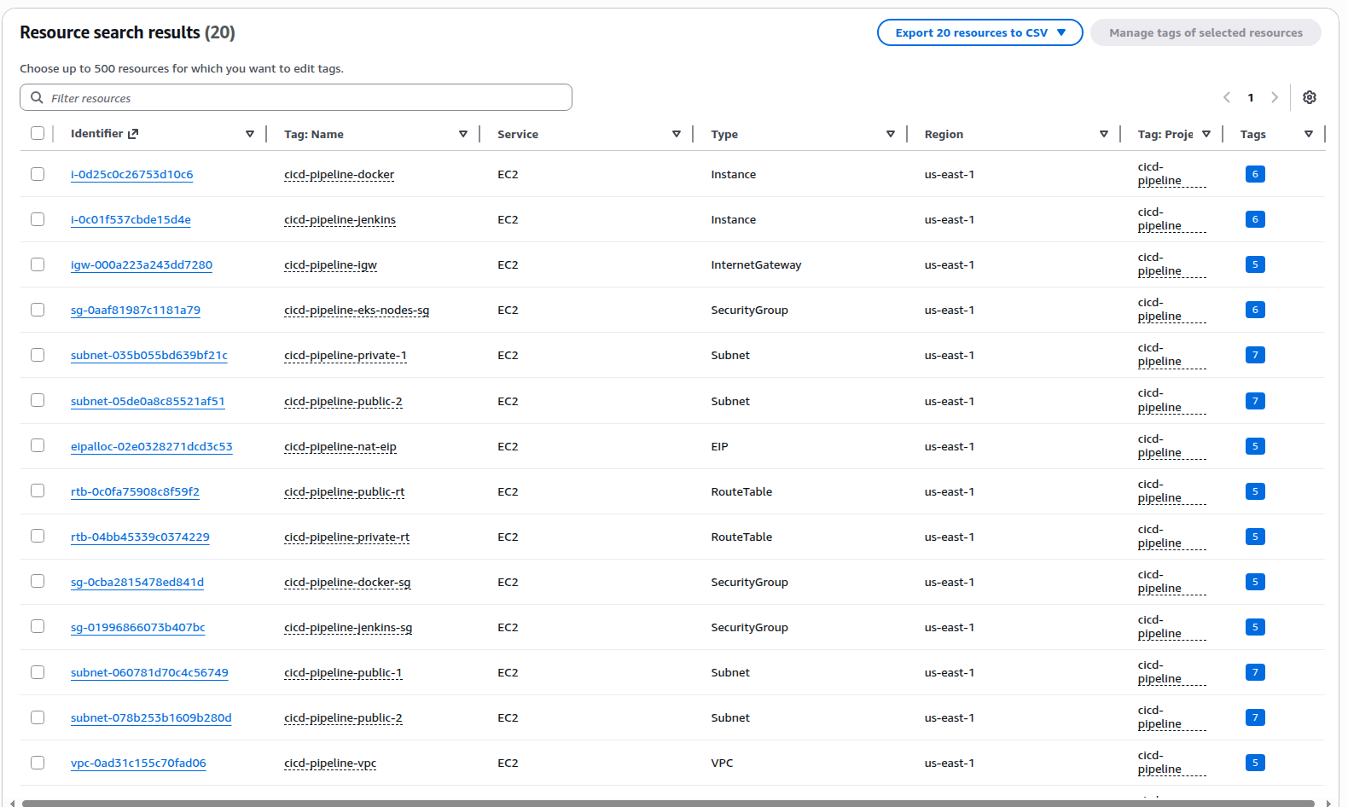
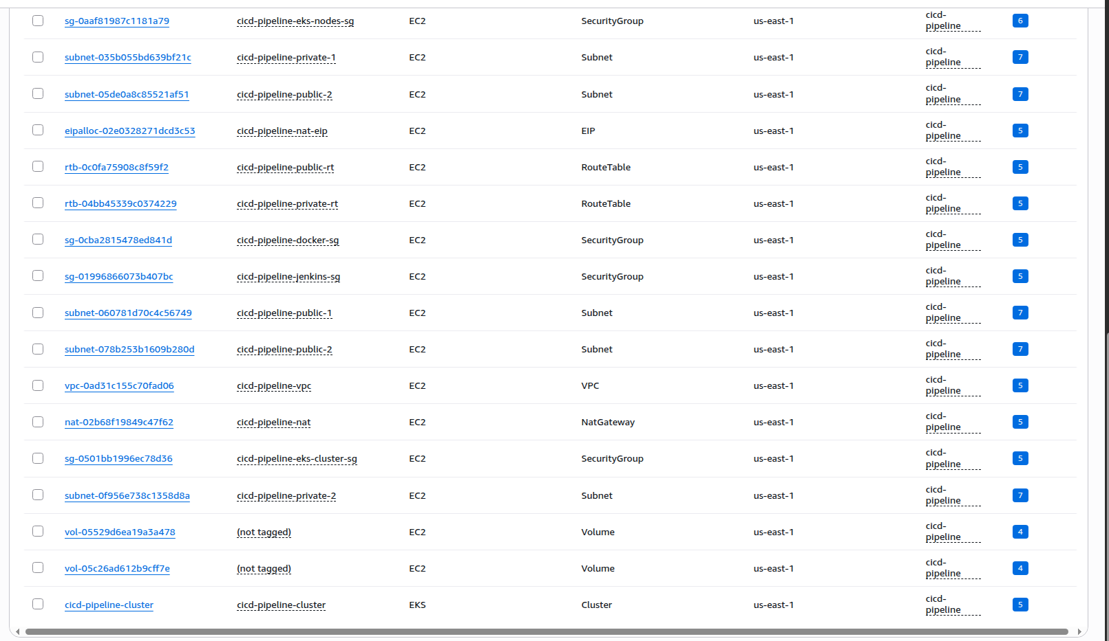

- With terraform, we already created a ec2 with jenkins inside. Now we can access to jenkins

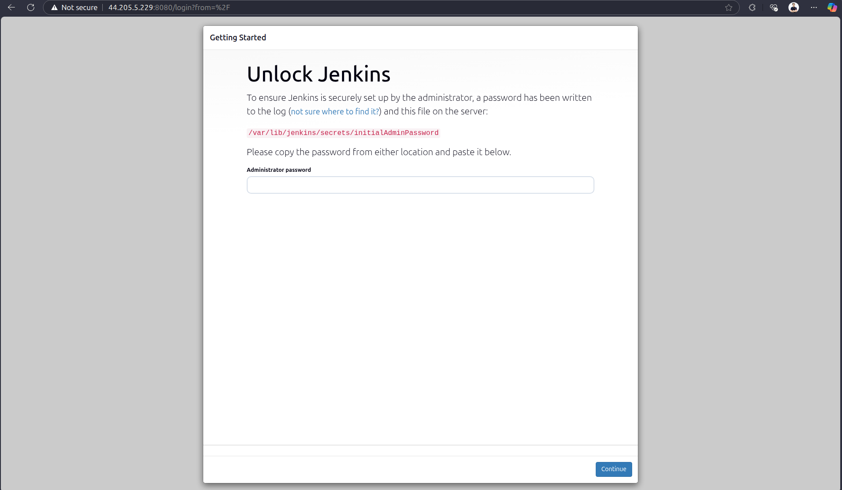
- For the first running, we need to get initialAdminPassword through the path jenkins provided

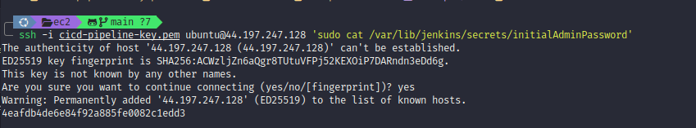
- Then we can login to the jenkins

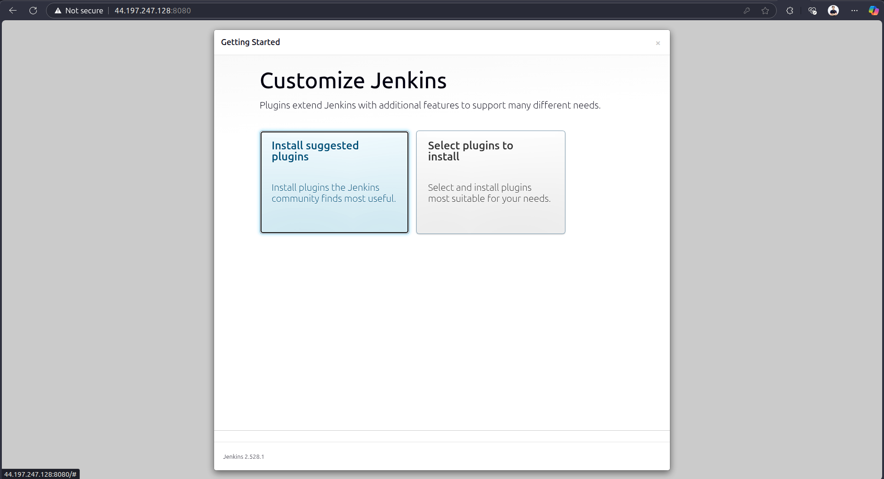
- We can select to install suggested plugins by Jenkins or select plugins you want to install. After installing, we can go to Jenkins dashboard

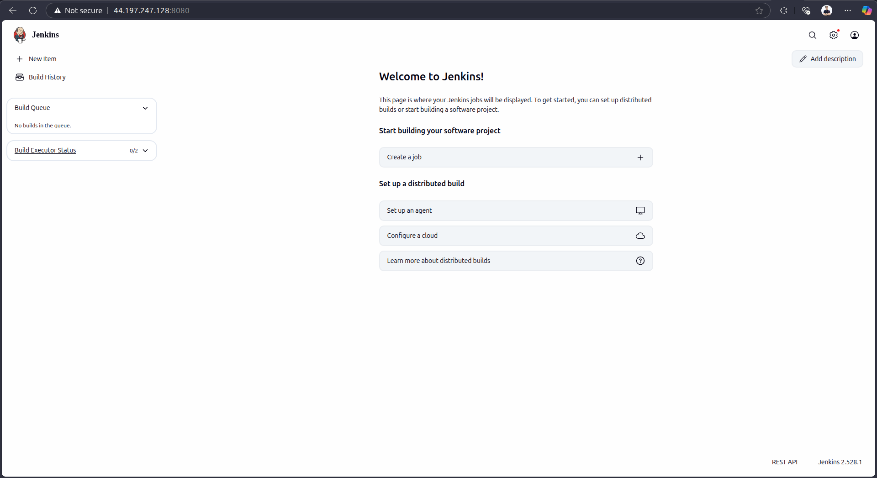
- To run CI/CD, we also need to install some plugins
  - Docker
  - Docker Pipeline
  - Pipeline
  - AWS Steps
  - Credential Binding
  - Git

Deploy MSA application to EKS using Jenkins CI/CD
- We need a MSA repo including frontend and backend: https://github.com/tuankiet1709/sd5055_msa
- To run CI on Jenkins, we need to define a Jenkinsfile in BE and FE sources.
- Jenkinsfile will define which agent use to run CI, the stage of CI is a step to install, build, validate, test, and push to ECR
  - https://github.com/tuankiet1709/sd5055_msa/blob/main/backend/Jenkinsfile
  - https://github.com/tuankiet1709/sd5055_msa/blob/main/frontend/Jenkinsfile
- When we already have a jenkinsfile, we need to config Jenkins to allow access to MSA repository and AWS resources
  - We need to create github access token to allow Jenkins access to msa repo
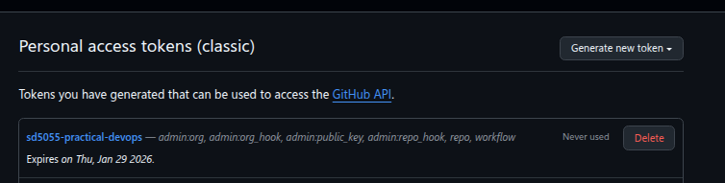
    - Click on user → Setting → Developer settings → Personal access tokens → Tokens (Classic) → Generate new token (classic) → Put token name and select scopes to allow Jenkins access to github → Create
  - We also need to create github webhook to trigger Jenkins whenever we push new code
    - In sd5055-msa repo → go to Settings → webhooks → Add webhook → we will input jenkins url with /github-webhook (for example: http://34.237.2.5:8080/github-webhook/)
  - We need to create some credentials in Jenkins which allow Jenkins access to Resources (Go to Jenkins Credentials → Click on (global) → Add Credentials)
    - AWS Account ID: The AWS Account ID
    - AWS Access Key ID: The AWS Access Key ID to access aws resources
    - AWS Secret Access Key: The AWS Secret Access Key ID to access AWS resources
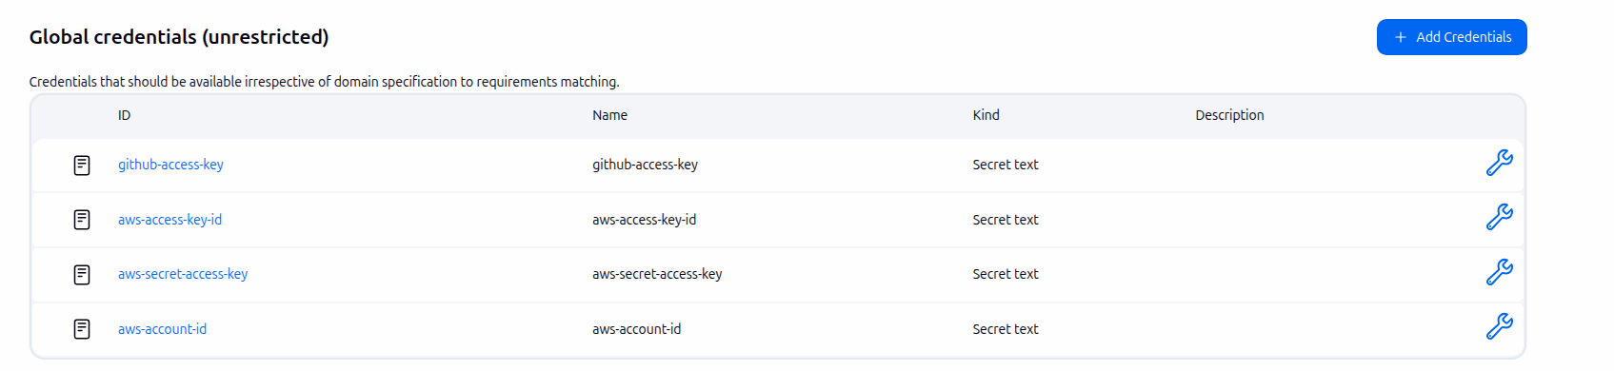
    - Github Token Key: The key to allow Jenkins access to github resources (We already created above)
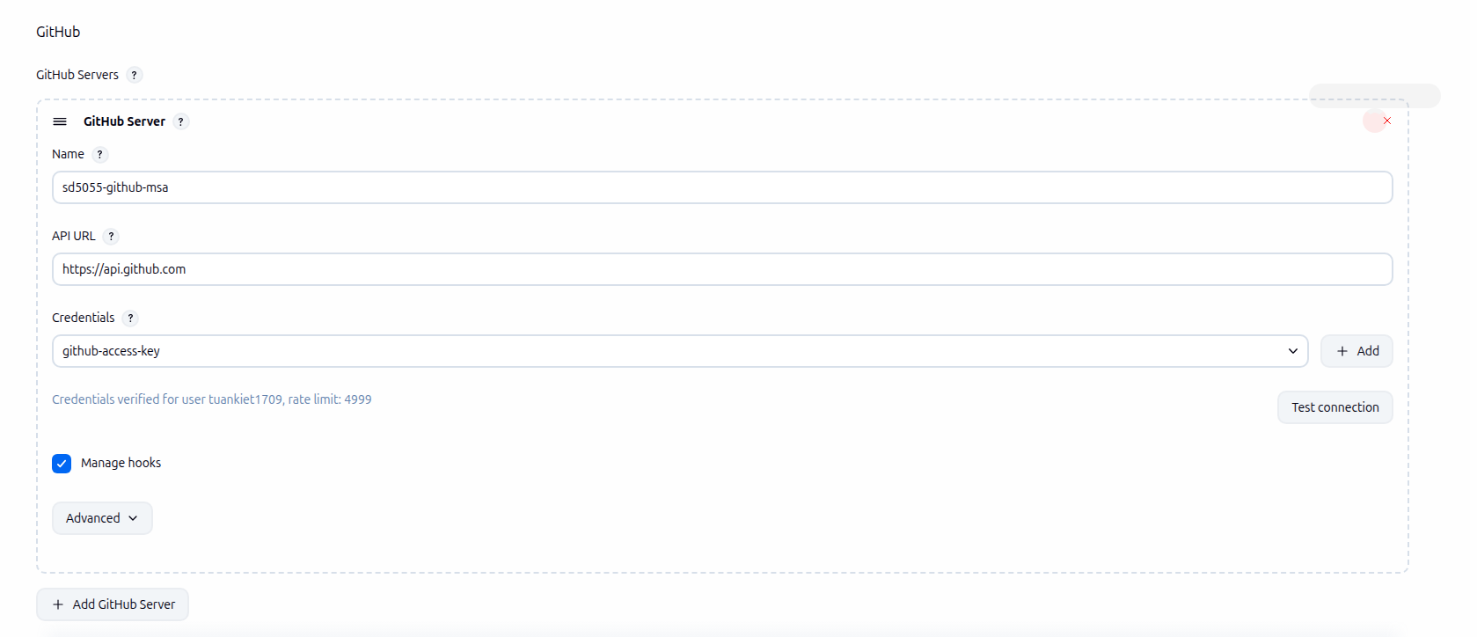
  - Add Github Server for Jenkins (Go to Jenkins settings → in Github section → Add Github Server with name → Credentials → Select github-access-key

- Next, we will create job to run CI for MSA Application
  - Frontend
  - Create multibranch pipeline job
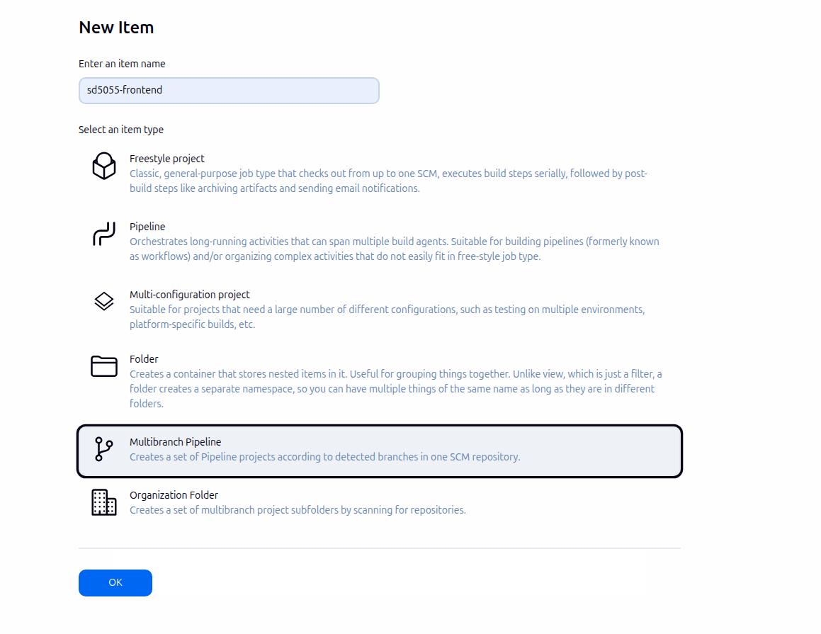
  - Configure Jenkins job, point to frontend branch source and jenkinsfile of frontend
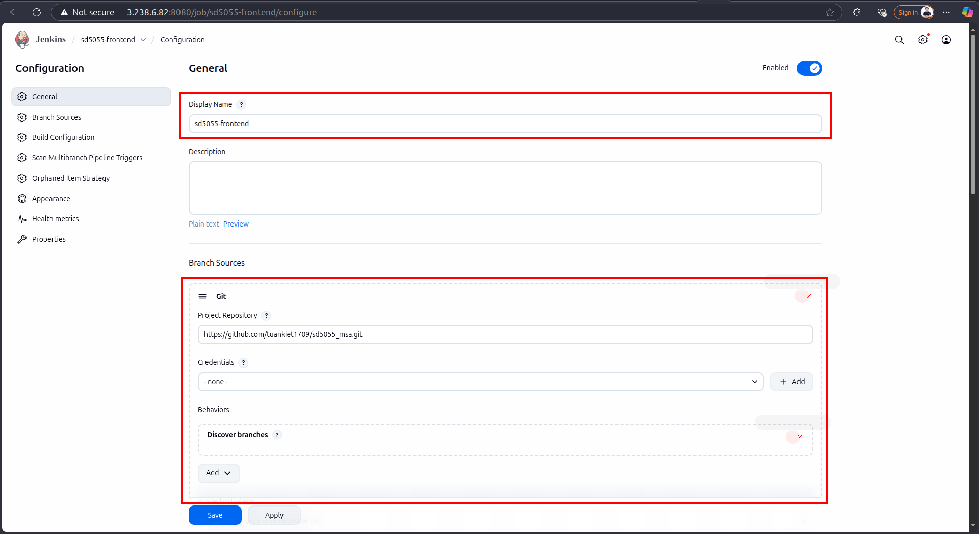
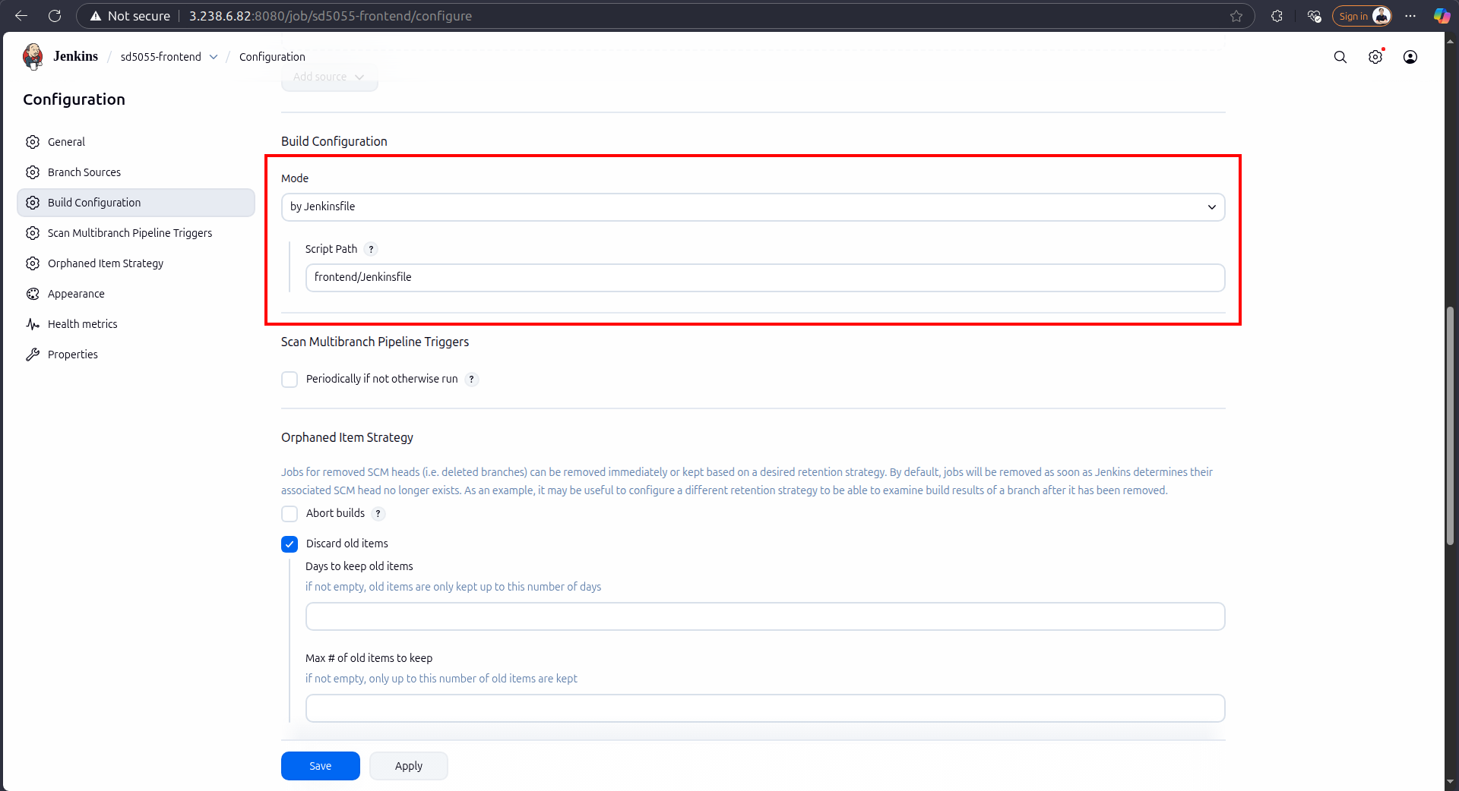
  - After creating, the job will run jenkins based on the jenkins file and source
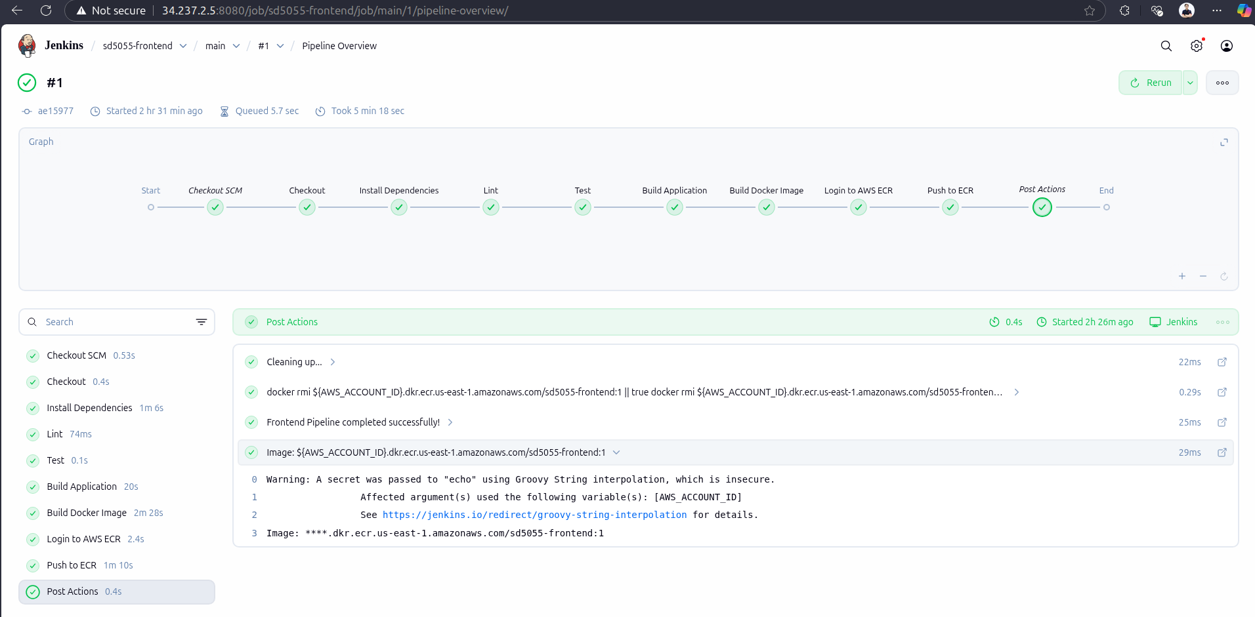
  - Once the CI run successfully, it will push the image to ECR
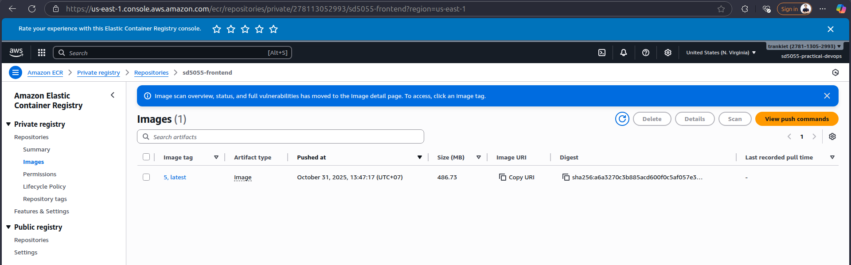
  - Backend
  - Setup the same as frontend
  - Create a new multibranch job
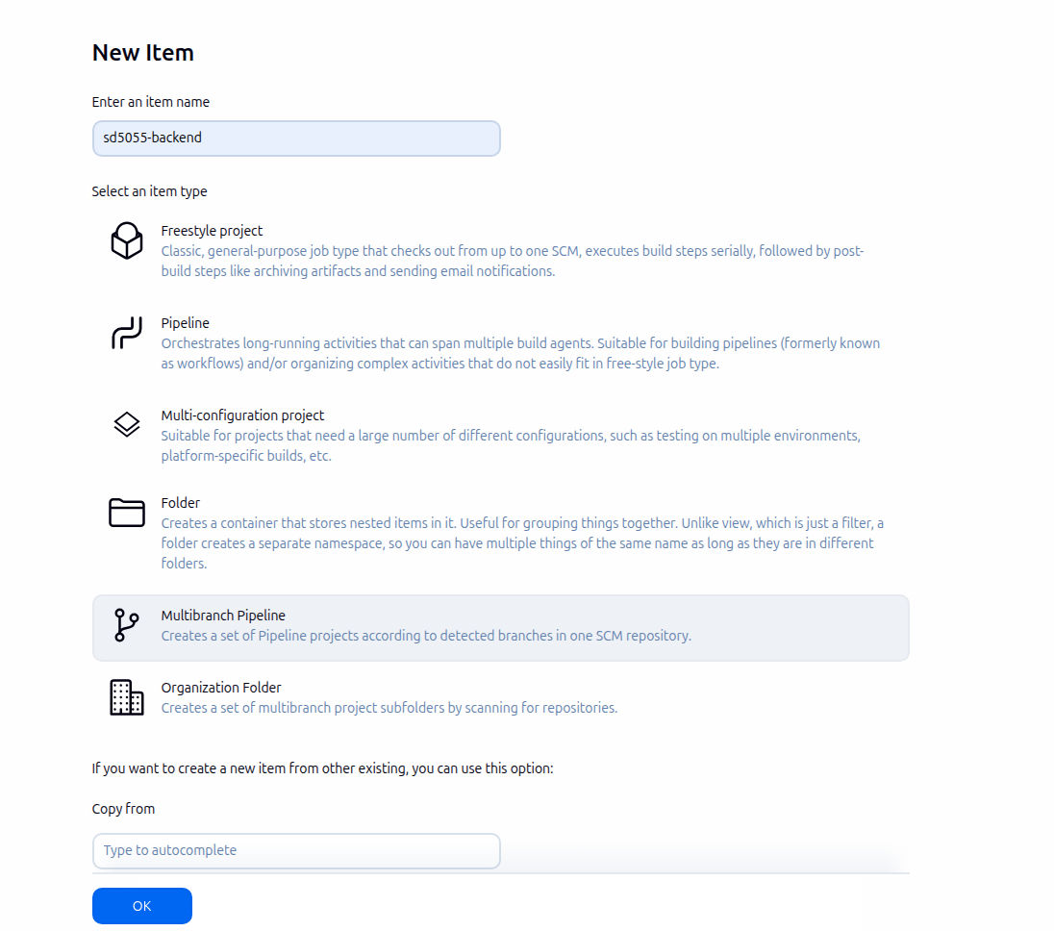
  - Configure Jenkins job, point to backend branch source and jenkinsfile of backend

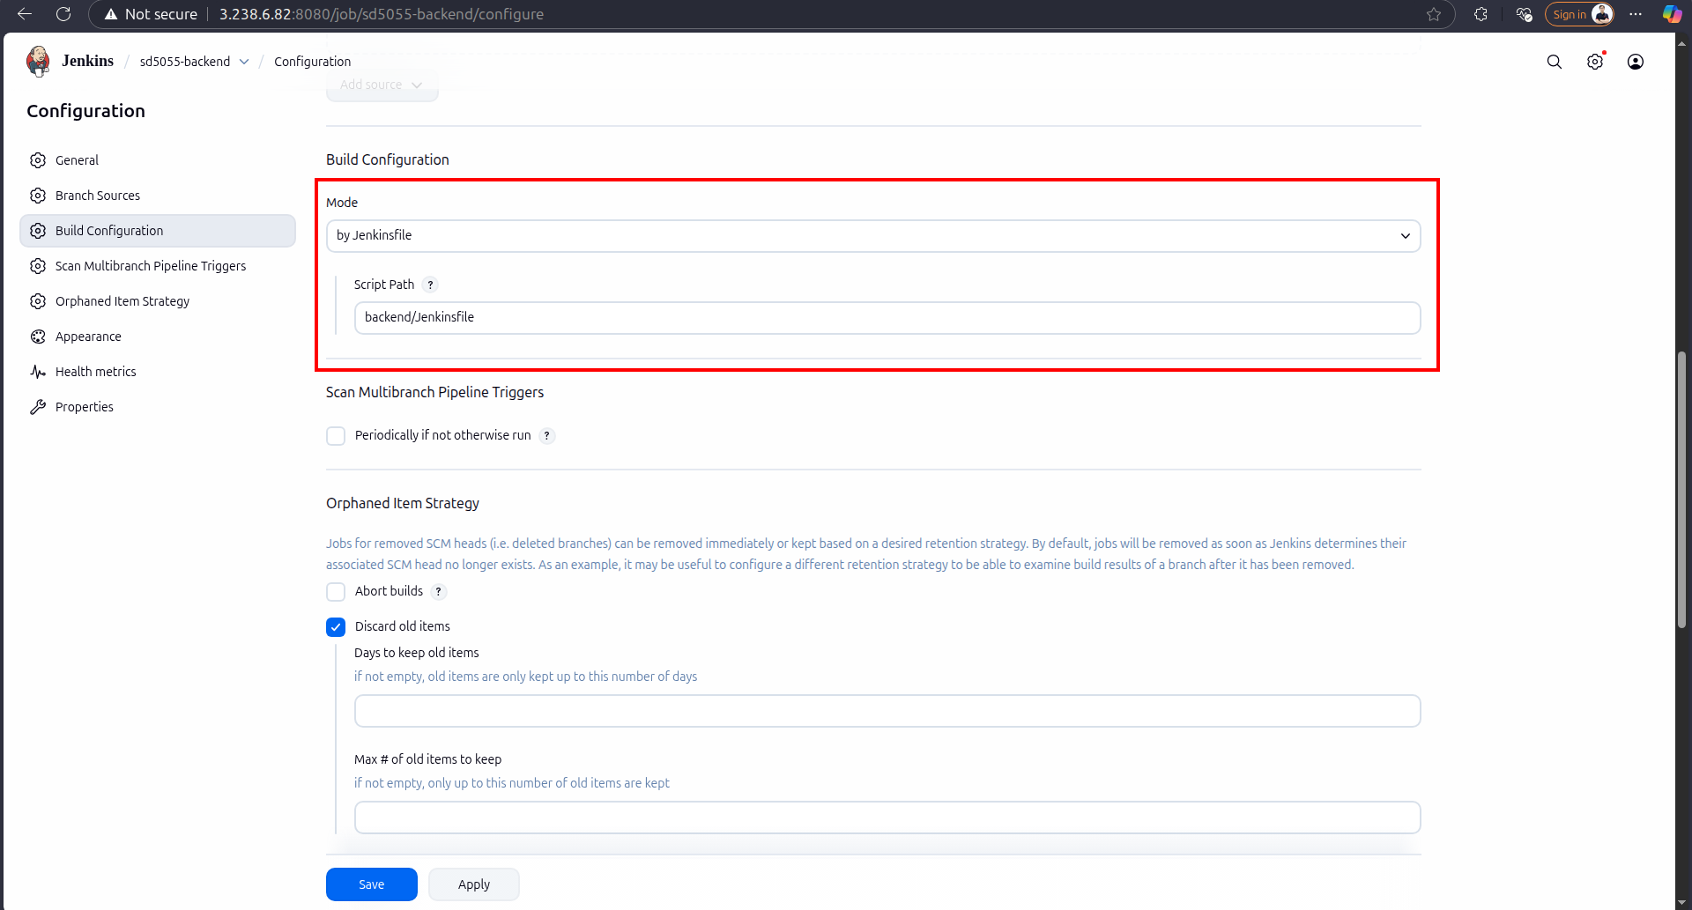
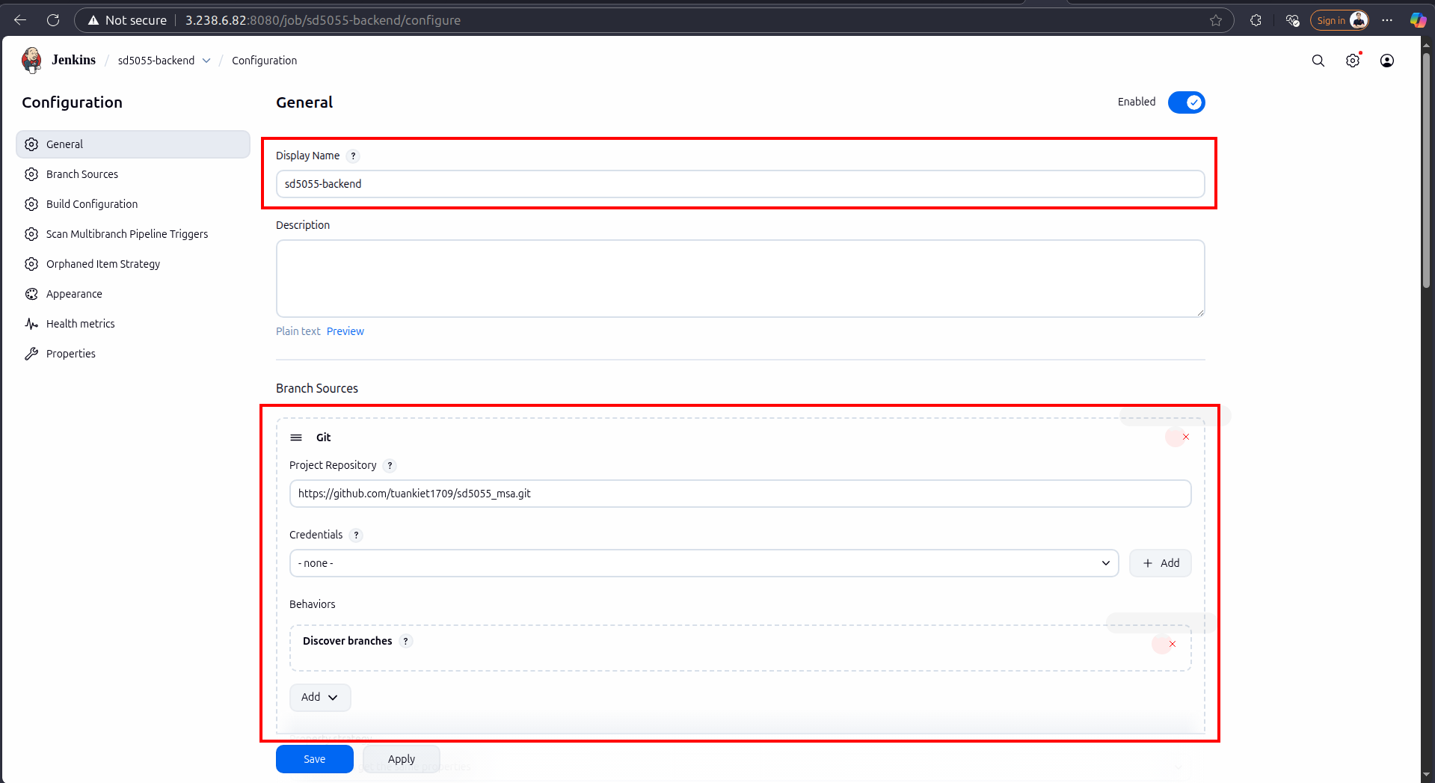
  - After creating, the job will run jenkins based on the jenkins file and source
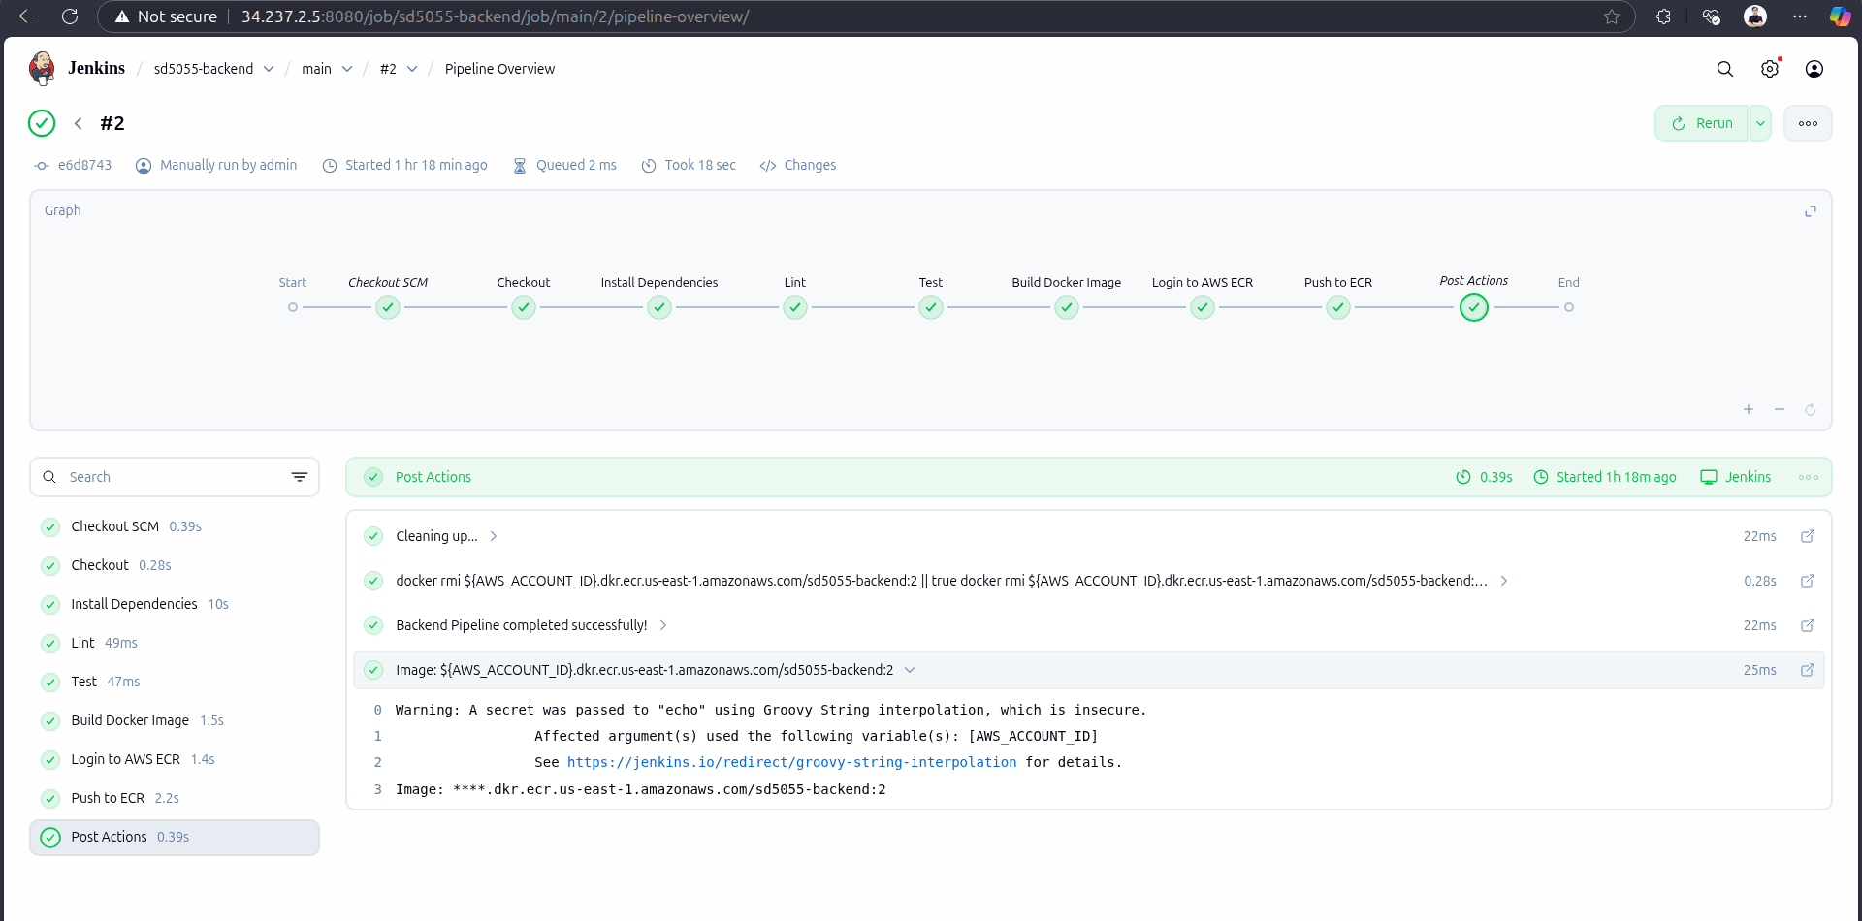
  - Once the CI run successfully, it will push the image to ECR
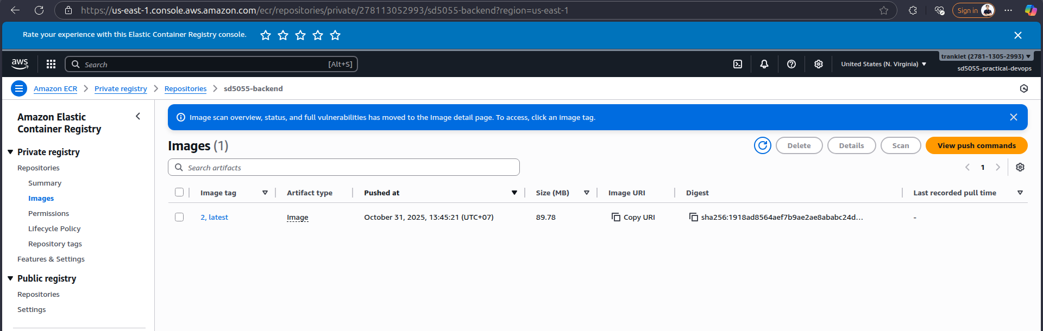

Deploy with ArgoCD
- Refer to source code: https://github.com/tuankiet1709/sd5055_devops_cicd_deployment/tree/main/argocd-deployment
- Install ArgoCD cli
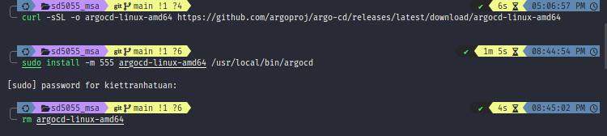
- Create an ArgoCD namespace on EKS
- Install ArgoCD to argocd namespace in eks
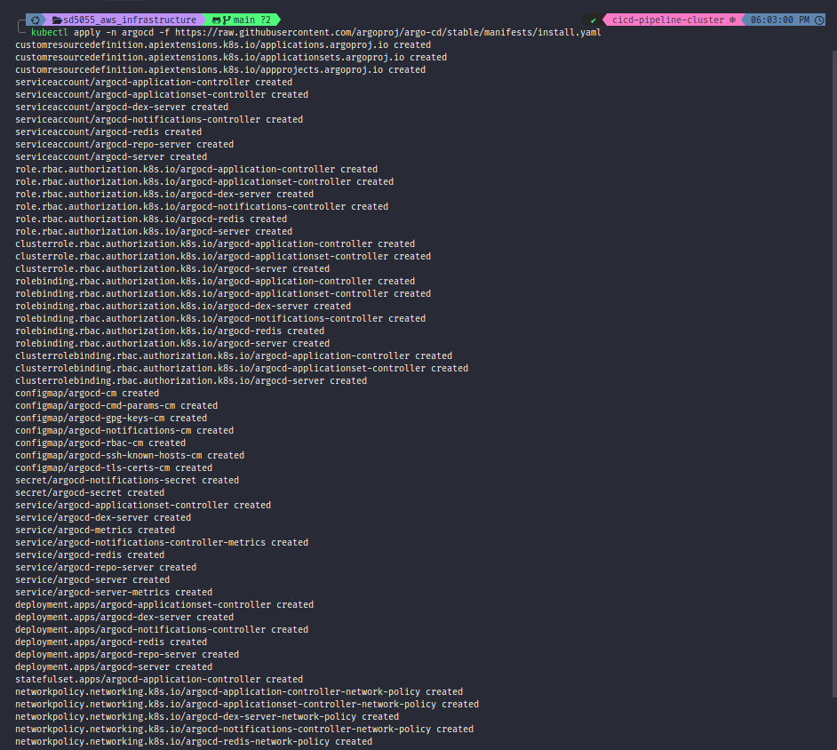
- Get pods from argocd namespace. The pods is created
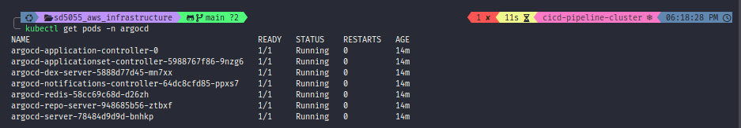
- Get ArgoCD initial password.
- We need to decode password from base64 (My password is erAoXancAJbhoie8)
- Forward ArgoCD port from EKS to local
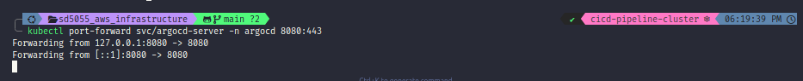
- Access to ArgoCD successfully
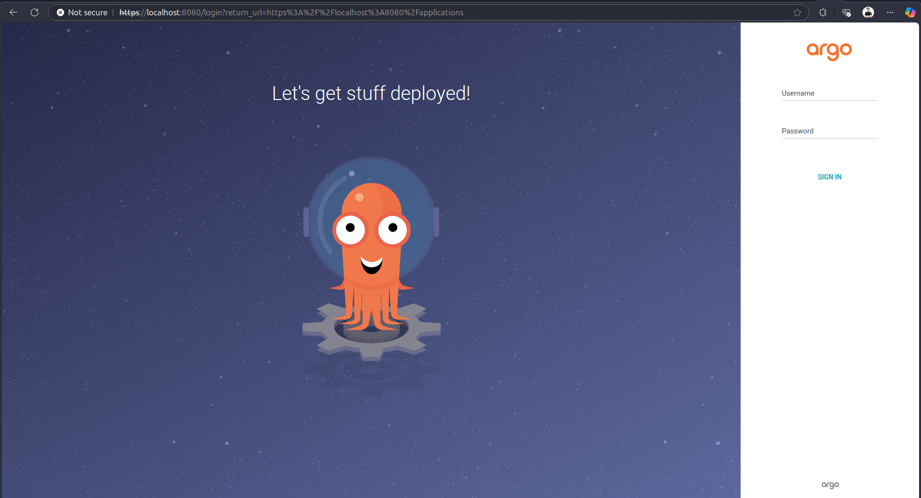
- Login to ArgoCD successfully with decode password
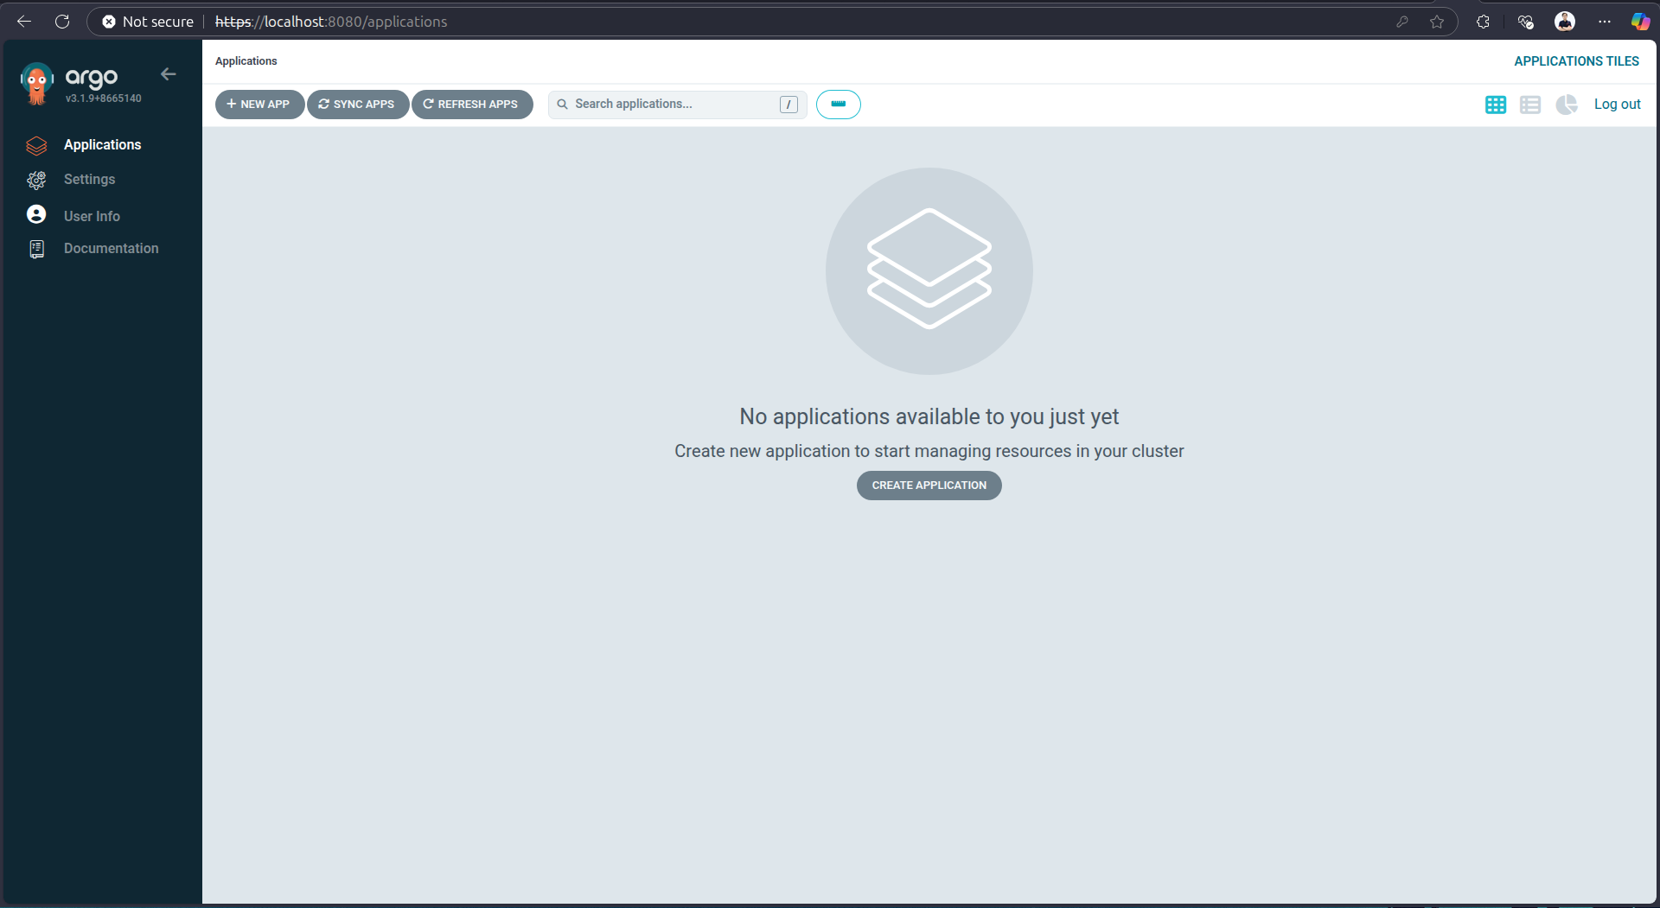
- Login to ArgoCD cli
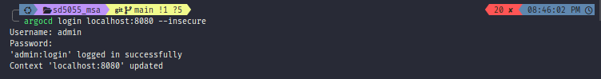
- Use ecr-secret script to create ecr in eks. This help argocd can pull image from ecr inside eks
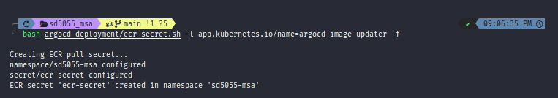
- Add sd5055_msa repo to argocd
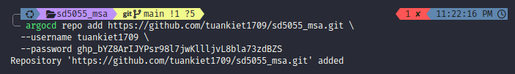
- Use application.yaml file to create sd5055_msa app in argocd
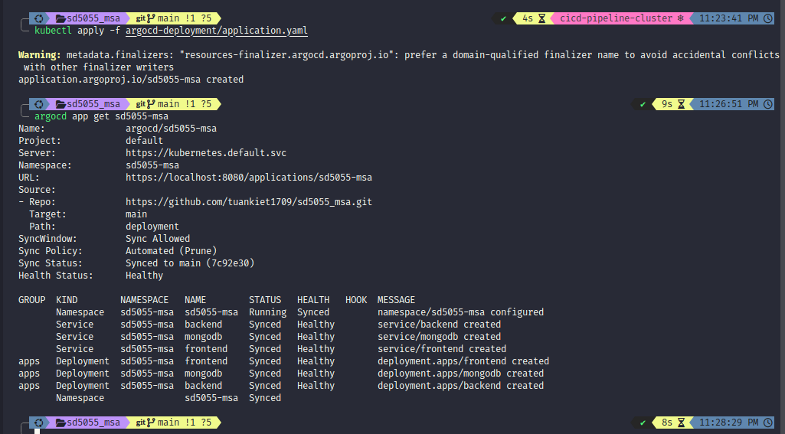
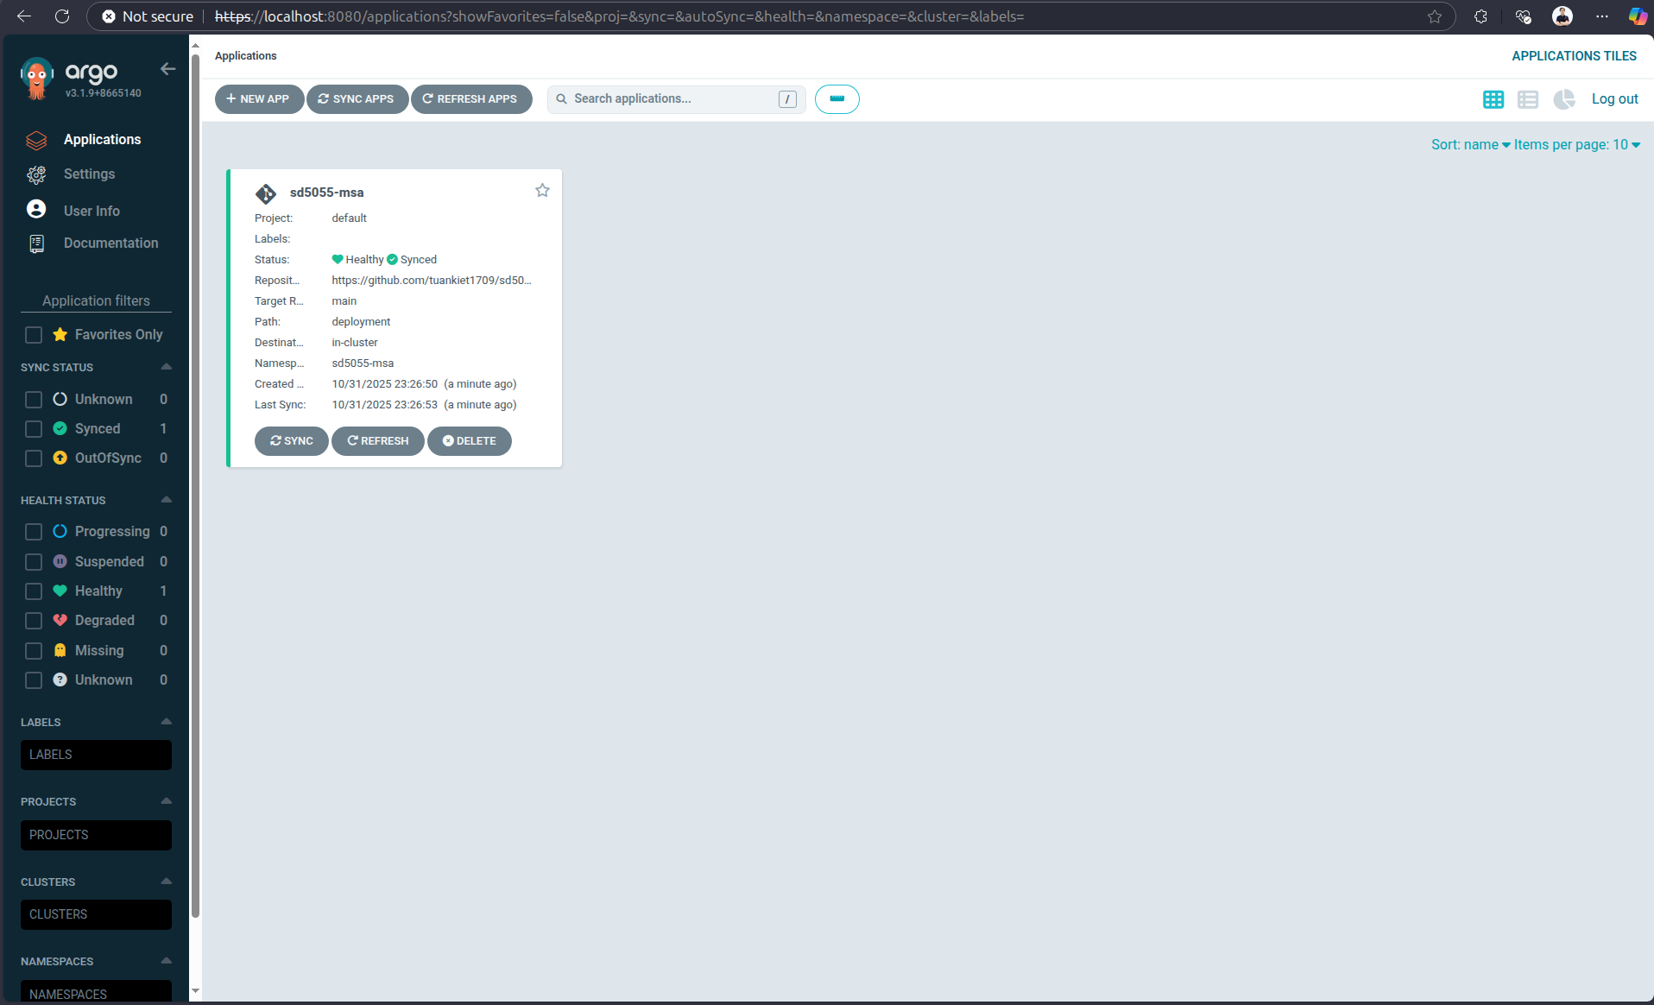
- Use image-updater-config.yaml to apply image in ecr-secret to argocd
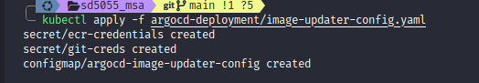

- The MSA application has been already deployed to eks
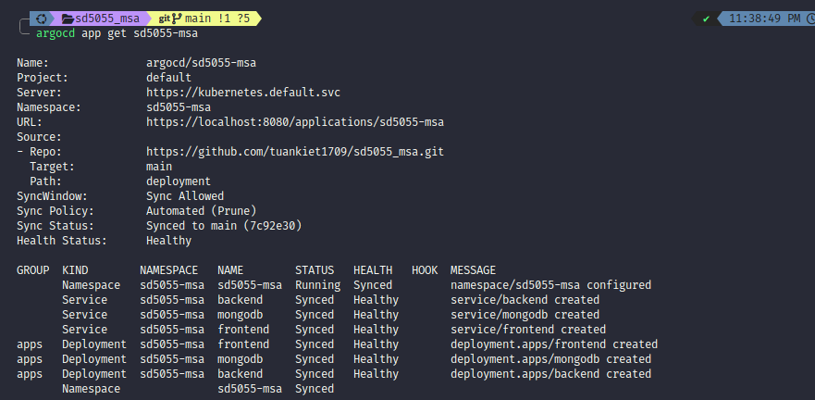
- MSA services in sd5055-msa is runnung
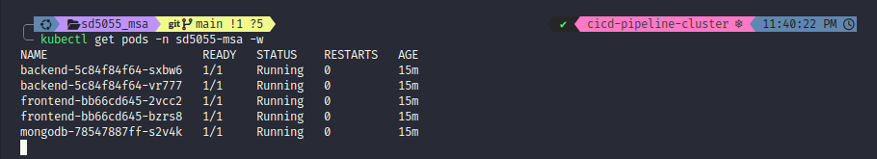
- Get frontend URL from sd5055-msa namespace
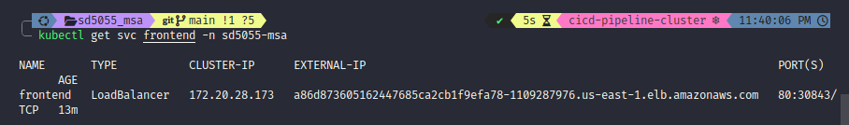
- Able to access to application
